# Global and historical meta-analysis of albacore tuna diet patterns and prey guilds

A working title and outline document for the global review of albacore tuna diets undertaken in 2019.

## Authors

Natasha A. Hardy, [Cindy Matuch](mailto:matuchie@yahoo.com), [Zachary Roote](mailto:zroote@ualberta.ca), [Iris George](mailto:igeorge@ualberta.ca), Barb Muhling, Michael Jacox, Elliott Hazen, Steven Bograd, [Larry B. Crowder](mailto:lbcrowd@stanford.edu), Stephanie J. Green

## Affiliations

FOLKS TO FILL OUT THEIR AFFILIATIONS

Barb:

1Institute of Marine Sciences, University of California, Santa Cruz, Santa Cruz, CA, United States

2NOAA Southwest Fisheries Science Center, San Diego, CA, United States

Steven:

1NOAA Southwest Fisheries Science Center, Monterey, CA, United States

1Institute of Marine Sciences, University of California, Santa Cruz, Santa Cruz, CA, United States

Mike:

NOAA Southwest Fisheries Science Center, Monterey, CA, United States

NOAA Physical Sciences Laboratory, Boulder, CO, United States

## Target Journal(s):

1. Fish & Fisheries (6.7)
2. Global Ecology and Biogeography (5.67)

## 

## Keywords/Themes

* Highly migratory marine species (HMS)
* Macro-ecology
* Pelagic predators
* Predator-prey interactions
* Resource use
* Trait-based ecology
* Also community ecology, foraging ecology, forage fish

## 

## Abstract

Words = 233. (Aim <250).

Humans are rapidly altering complex and poorly understood ecosystems, through climate change and intensive global fishing. We face significant analytical challenges in modelling and projecting changes in distributions and productivity of large, mobile and commercially valuable predators in relation to changing and complex ecosystems. We posit that this challenge can be addressed using trait-based frameworks to model and synthesise complex trophic interactions. Here, we reconstruct the historical and cross-basin resource use of a highly-migratory pelagic predator and an important fisheries species, albacore tuna (*Thunnus alalunga*), using functional traits to synthesise predator-prey relationships. We present the biological and trait-based diversity in the diets of albacore tuna globally, including over **300** prey species consumed. We synthesize that diversity to 7 key functional prey guilds based on habitat association, life stage consumed and aggregation behaviour in over **150** albacore prey species for which we obtained complete trait information. Using either the individual trait values and functional prey guilds, we captured broad trait-based patterns in the diets of these dynamic predators and revealed significant geographic signatures in albacore diets with greater explanatory power than multivariate models fitted to species taxonomic identities alone. In addition to providing important biogeographic contingency to current food web modelling efforts, we propose the use of reproducible prey guilds and trait-based predictors for modelling shifts in these predator’s diets and resource use in the context of changing environmental and ecological states.

## Table of Contents

Global and historical meta-analysis of albacore tuna diet patterns and prey guilds

Authors

Affiliations

Journal selection

Keywords/Themes

Abstract

Table of Contents

Introduction

Methods

Historical diet data collation

Tuna and prey size and age class estimation

Prey trait information collection

Trait-based analyses of historical albacore diet data

Synthesis

Biological and trait diversity in diets of a highly migratory predator

Prey typologies identified in the diets of albacore tuna

Trait variation in albacore diet across geographies

Towards prediction… predicting an albacore prey item??? This will likely be the conclusion section.

Conclusions

TO-DO’s:

Inspiration papers

Data Accessibility

Figures & Tables

Electronic Supplementary Material

## Introduction

Words = 648. (Aim ~ 800).

Open-ocean and deep-sea pelagic ecosystems are among the last remaining frontiers on Earth. Humans are rapidly altering dynamic and poorly understood marine systems through climate change and intensive fishing [(Casini et al., 2009; Möllmann et al., 2009; Poloczanska et al., 2016; Polovina et al., 2011)](https://www.zotero.org/google-docs/?Qlfn80). Changes to species distributions and community reassembly [(Hazen et al., 2013; Morley et al., 2018)](https://www.zotero.org/google-docs/?54Izra), widespread species extirpations and the emergence of interim ecosystem states [(Molinos et al., 2016; Vergés et al., 2019)](https://www.zotero.org/google-docs/?FFPXlY) threaten the spatio-temporal stability and productivity of marine ecosystems. Ultimately, altered pelagic ecosystem states translate to changes in global fisheries production [(Blenckner et al., 2015; Brander, 2007; Free et al., 2019)](https://www.zotero.org/google-docs/?2dK9ku).

Highly migratory pelagic predators, such as tunas and billfishes, contribute to high-value and extensive international fisheries. These species have evolved to undertake large, basin-scale movements likely in relation to exploiting seasonal food web productivity, advantageous to their growth, and warmer waters advantageous for reproduction [(Block et al., 2005; Mariani et al., 2016; Nikolic et al., 2017)](https://www.zotero.org/google-docs/?etJ7j8). Anomalies, oscillations and overall changes in climate produce asynchronies between resource productivity, highly migratory predators and fisheries productivity [(Lan et al., 2020; Scheffers et al., 2016; Thackeray et al., 2010)](https://www.zotero.org/google-docs/?Lw8Vw4). Modelling trophic interactions is often the missing link in ecological forecasting for species redistributions under climate change [(Green et al., 2020; Lan et al., 2021)](https://www.zotero.org/google-docs/?CyFbCe), especially involving highly migratory marine species [(Muhling et al., 2019)](https://www.zotero.org/google-docs/?XnI5I9). But tropho-dynamic modelling and species distribution modelling based on trophic interactions remain plagued by the mathematical complexities of large numbers of interacting species [(Carroll et al., 2019)](https://www.zotero.org/google-docs/?PIZ8N0). Taxonomic specificity, mathematically large ecosystem biodiversity and a lack of synthetic ecological indicators for trophic interactions likely limit predictive modelling in complex systems to date. There is thus a need to model functional ecological relationships using generalisable parameters.

Trait-based approaches to modelling predator-prey interactions aim to simplify complex arrays of interactions from hundreds of species to synthetic non-taxonomic predictors for those relationships [(Arrizabalaga‐Escudero et al., 2019; Green et al., 2020; Green & Côté, 2014; Kiørboe et al., 2018)](https://www.zotero.org/google-docs/?n6oAQX). Tunas are largely held to be diet generalists [(Duffy et al., 2017; Pethybridge et al., 2018)](https://www.zotero.org/google-docs/?njLE5Y), and thus make salient indicator species for changing prey communities and food web dynamics under climate change, in addition to requiring synthetic, trait-based ecological tools to model their interactions with prey species. Several synthetic macro-ecological studies revealed shifts in the foraging ecology of yellowfin, bluefin, bigeye and albacore tunas across latitude and life history, as well as niche partitioning between species or age groups [(Duffy et al., 2017; Pethybridge et al., 2018; J. W. Young et al., 2015)](https://www.zotero.org/google-docs/?nIvLrV). Additionally, tuna diets were effectively modelled in relation to environmental drivers [(Pethybridge et al., 2018)](https://www.zotero.org/google-docs/?1UVaD5) (+ [extra text from the meta-analysis](https://docs.google.com/document/d/1XoFRAo2-xoBWEQgCNOqNM9ZEExxogv9vvNoXPC2tLdY/edit)). Diet diversity and taxonomic specificity remain significant hurdles for further modelling and prediction of tuna resource use in relation to environmental gradients of change.

We seek to expand on traditionally descriptive analyses and identify non-taxonomic predictors for trophic relationships in highly-migratory pelagic predators and commercially valuable species, using albacore tuna as a case study. Our synthesis aggregates data sources for albacore tuna diets from published and grey literature and ultimately provides important baseline information on their historical resource use across the world’s oceans, salient in a changing world. Our aims are threefold: (i) to present the ecological trait diversity of albacore tuna prey species in relation to the reported biodiversity consumed, (ii) synthesise functional trait-based prey typologies that can be applied to models of shifting trophic interactions in dynamic pelagic food webs under climate change, and (iii) model variation in albacore tuna diets as a function of trait-based predictors, geography and predator life stage. We predict that models fit to species traits, as well as those fit to prey guilds, in relation to environmental variables and species identities will outperform taxonomic-based models in explaining historical diet variation in albacore tuna across ocean basins and albacore tuna life stage sampled.

## Methods

Words = 1246. (Aim ~1000-1250).

### 2.1 Historical diet data collation

We compiled published and grey literature for albacore tuna diets by searching the Web of Science [(Clarivate Analytics, 2020)](https://www.zotero.org/google-docs/?UdDKhL), Aquatic Sciences and Fisheries Abstracts [(ASFA, 2020)](https://www.zotero.org/google-docs/?PYAc4J) and Federal Science Library Canada [(FSLN, 2020)](https://www.zotero.org/google-docs/?MkiSiB) bibliographic databases, queried from 1900 until 2020 using diet research search terms and synonymous scientific names for albacore tuna (*Thunnus alalunga*) (Table S1, [ESM](https://docs.google.com/document/d/1VNvPpuBC5vCvFNSpCnemlqkrWDuD7HLUTm8aO33Vzw0/edit)). We also included albacore diet reports or papers cited by articles accessed, research theses and historical reports dating back to the 1880’s. We obtained 61 relevant studies overall reporting on diets or foraging ecology of albacore tuna, including 3 papers that report on larval albacore tuna diets, as well as tagging studies and molecular analyses of albacore tuna foraging ecology.

Here, we used albacore tuna diet data obtained from historical stomach content analyses and that reported prey consumed to species taxonomic identification as well as reporting their contribution to albacore diets as percent frequency of occurrence of prey species occurrences across samples (Table S2, [ESM](https://docs.google.com/document/d/1VNvPpuBC5vCvFNSpCnemlqkrWDuD7HLUTm8aO33Vzw0/edit)). We therefore include data from 31 studies in this meta-analysis, containing detailed diet tables for albacore tuna stomach contents, yielding a total of 225 aggregate observations for juvenile and adult albacore tunas from 1880–2020 and representing diets from the Pacific, Atlantic and Indian Oceans, and the Mediterranean Sea (Figure 1). For every diet report, we recorded the date range, months and seasons of sampling, the median geographic location of albacore tuna collections, the number of albacore tuna collected, fishing gear and time of day for collections ([Supplementary Data 1](https://docs.google.com/spreadsheets/d/1RD1ipsaG7R-PpR3u2hMmHH6MeNsTfaPOLMH0mPvsF7U/edit#gid=750827646)). Albacore tunas were typically collected either via scientific sampling programs (i.e., NOAA, CNRS), or in collaboration with commercial fishing operations [(Bello, 1999; Glaser et al., 2015)](https://www.zotero.org/google-docs/?Y63U9X), and using surface troll or longlining at specified depths. We recorded diet observations at the highest level of detail reported by papers, typically for geographic location and year sampled (Table S2). We digitised all data and historical reports (Table S2, [ESM](https://docs.google.com/document/d/1VNvPpuBC5vCvFNSpCnemlqkrWDuD7HLUTm8aO33Vzw0/edit), [Supplementary Data pdfs](https://drive.google.com/drive/u/1/folders/1LUsYmoUfYwGpx9Z0Jxkqumi42tVHSqEx)).

### 2.2 Estimation of size and age class of tuna and their prey

For trait-based analyses of prey consumed, our goal was to use trait information that is appropriate to the life history of the prey consumed. Length data or estimates for prey consumed were rarely provided in albacore diet analyses, largely due to the digested nature of stomach contents. Length data for albacore tuna were typically reported for each study. Where albacore tuna fork lengths were not reported, we used ocean basin-specific age and growth curves to estimate the mean fork length for albacore tuna given a reported age, or life history stage, and location (Pacific Ocean, [Xu et al., 2014](https://www.zotero.org/google-docs/?LzWq4c); Atlantic Ocean and Mediterranean, [ICCAT, 2020](https://www.zotero.org/google-docs/?ihRciJ); [Supplementary Data 2](https://docs.google.com/spreadsheets/d/1RD1ipsaG7R-PpR3u2hMmHH6MeNsTfaPOLMH0mPvsF7U/edit#gid=920777994)).

We then estimated the probable life stage (e.g., adult, juvenile, larva) of the prey species consumed based on the following information: (i) the maxillary length or gape length limit of yellowfin tunas as a proxy for albacore tunas given their reported or estimated fork length (maxillary length = fork length*0.0823+1.758; equation for yellowfin tunas; [(Ménard et al., 2006)](https://www.zotero.org/google-docs/?MEPSts), (ii) the known maximum length (Lmax), length at maturity (Lmat) and larval length for each prey species (typically from FishBase or SeaLifeBase, 2020), and/or (iii) where no known Lmax, Lmat or larval length were recorded for a species, we used relationships of Lmax, Lmat, and larval length for the next nearest taxonomic clade (genus or family) for that species (Supplementary Data 3)

### 2.3 Prey trait information collection

We gathered information for prey species traits appropriate to the life history stage consumed (i.e., larva, juvenile, adult). We collected trait information for: (i) habitat association, as well as (ii) aggregation and predator-avoidance behaviours and compiled these in a publicly available database (cite data publication). These data were compiled using online repositories for species-level information, primarily FishBase [(Froese & Pauly, 2020)](https://www.zotero.org/google-docs/?s7hAuE), SeaLifeBase [(Palomares & Pauly, 2020)](https://www.zotero.org/google-docs/?9S5urm), and the IUCN Red List of Threatened Species [(IUCN, 2020)](https://www.zotero.org/google-docs/?iPv6WS), and by searching descriptive published literature for each species using Web of Science and Google Scholar (Gleiber et al. *in prep* trait data collection protocol). Albacore prey species trait database and trait query metainformation are available (Hardy et al. data pub -- [Albacore_prey_data_publication](https://docs.google.com/document/d/1nlcFRpNKq19uL1k7SpDCxmfzLZaNYI4mM6aBzLqedzk/edit)).

### 2.4 Trait-based analyses of historical albacore diet data

**Phylogeny.** We present the biological and trait-based diversity of prey species by integrating species-specific trait information across phylogenetic trees in R (packages included: ggplot2, *ggtree, Biostrings, rotl, taxize, treeio, phylobase, phytools, stringr, phangorn, ggnewscale*; code found under ‘Albacore_synthesis_a_phylo.Rmd’ and ‘Albacore_synthesis_a.Rmd’) [(R Core Team, 2020)](https://www.zotero.org/google-docs/?9duwDS).

**Prey typologies.** We identified key prey typologies or functional groups in albacore tuna diets using hierarchical clustering calculated with divisive algorithms [(Jain et al., 1999; Legendre & Legendre, 1998)](https://www.zotero.org/google-docs/?koMSt1) on a Gower dissimilarity matrix [(Gower, 1971)](https://www.zotero.org/google-docs/?Fep4r4) to identify relational structure between mixed ecological trait types: 3 binomial variables and 2 categorical variables for prey species traits (packages included: *cluster, vegan* and *dendextend*; code found under ‘Albacore_synthesis_b.Rmd’). Our objective in clustering selection [(Brock et al., 2008; Charrad et al., 2014; Theodoridis & Koutroumbas, 2006)](https://www.zotero.org/google-docs/?qKOMax) is to optimise the number of clusters based on (1) maximum differentiation or separation of species between clusters, (2) minimum differentiation of species or compactness within clusters, (3) optimal silhouette width coefficient value as well as Dunny Smith residuals, and (4) evenness or balance of cluster composition (number of species in each cluster). We assessed clusters visually for balance and consistency using cluster dendrograms and trait values that influenced a species’ occupancy within a cluster are visualised using heatmaps. The relative position of species to each other in relation to their cluster occupancy, and based on shared or separation of trait values, was visualised using multivariate ordination-based, non-metric multidimensional scaling (nMDS) [(Field et al., 1982)](https://www.zotero.org/google-docs/?rP0BUe).

**Trait-based multivariate analyses.** We investigated how prey species’ functional traits performed in explaining differences in albacore tuna diet composition in relation to (i) albacore tuna age class (adult, juvenile or mixed), and (ii) geography (ocean basins in the northern and southern hemispheres) using a multi-matrix approach [(Brown et al., 2014)](https://www.zotero.org/google-docs/?nj5qny). We used a fourth-corner model with binomial distribution on presence/absence diet composition data to predict the probability of occurrence of albacore prey species as a function of both prey species traits and explanatory variables (albacore age group and geography sampled).

Our trait-based model for global albacore diet assemblage variance was fitted using the function *traitglm* and a LASSO penalty, specifying the fitting method as ‘*glm1path’*, a method of penalised likelihood that imposes a constraint on estimates of model parameters [(Brown et al., 2014; Hastie et al., 2009; Warton et al., 2015)](https://www.zotero.org/google-docs/?Sx5PYO). This constraint shrinks coefficients to zero when not statistically significant, providing a combined approach for model selection and parameter estimation to evaluate the magnitude and significance of an explanatory variable [(Hastie et al., 2009)](https://www.zotero.org/google-docs/?zNFvDX), and performed using the package *mvabund* (version 4.1.9) [(Wang et al., 2012)](https://www.zotero.org/google-docs/?6pqX7i) in *R* software (version 4.0.4) [(R Core Team, 2020)](https://www.zotero.org/google-docs/?djfN0l). Model fit was assessed by plotting residuals against fitted values and plotting quantile-quantile (Q-Q) plots.

To determine species-level variation in prey composition not explained by traits, a single predictive model was fit for each prey species based on frequency of occurrence data as a function of albacore age groups and geography using a *traitglm*, equivalent to fitting a multivariate species distribution model (SDM). Broad trends, overdispersion and outliers in multivariate space were checked graphically by non-metric multi-dimensional scaling (nMDS) plots [(Field et al., 1982)](https://www.zotero.org/google-docs/?HkMNK8) using the *vegan* package (version 2.5-7) in *R* [(Oksanen et al., 2020)](https://www.zotero.org/google-docs/?G00YDd).

## Synthesis

Overall, we identified broad taxonomic and trait diversity in albacore diets globally and historically. Using relational, ecological traits information for albacore prey species, we identify significant trait-based variation in albacore diets at ocean basin scales and across albacore life history, namely in relation to information on prey species’ probable life stage consumed, their habitat use and aggregation behaviour. We propose and test synthetic functional groupings for albacore prey and highlight their utility for further food web and resource use analyses involving highly migratory marine predators in complex food webs. #Could expand narrative to include ‘conserved traits’ [noted here](https://docs.google.com/document/d/1Lwc3zY7pb3uXO9FobOS51yM_k7KL_gpx0-t1KVk3DHQ/edit) and do this using the phylogeny graphs.

### 3.1 Biological and trait diversity in diets of a highly migratory predator

Through a historical and global synthesis of albacore tuna diets using reported stomach content data from the 1880’s–2010’s, we report large biodiversity in the diets of albacore tuna. We report a total of **550** taxa identified in the diets of juvenile and adult albacore tuna across the world’s oceans, representing **203** families of prey taxa, mainly of ray-finned fishes (n = **108** families of prey), cephalopods (n = **29**), and crustaceans (Malacostraca n = **45**, Hexanauplia n = **6**), but also several taxa of pelagic gastropods (n = **6**), salps (n = **2**) as well as one hydrozoan (n = **1**), and one elasmobranch (n = 1) (Supplementary Data). Of these, **312** taxa were reported to species level. In addition to consumption data, we obtained reliable trait information, at the appropriate life stage likely consumed by albacore tuna for **298** individual species. We obtained quantitative data in the form of (i) percent frequency of occurrence for 137 species, (ii) percent numerical abundance for 100 species, and (iii) percent of biomass consumed for only 82 species.

Whilst broad diets are expected of generalist predators, and cumulatively we would expect several hundred taxa to be represented in a global list of prey consumed, there was no published summary of the taxonomic diversity identified within albacore diets beyond the compilation of a global dataset that is not yet available publicly [(J. W. Young et al., 2015)](https://www.zotero.org/google-docs/?aoNc6E). Additionally, no data from the North Pacific were used in previous syntheses of albacore and other tunas [(Duffy et al., 2017; Pethybridge et al., 2018)](https://www.zotero.org/google-docs/?pnSpJs). We identify a large diversity of taxa consumed in the productive NE Pacific across the multiple years of historical data included in this review for this region (1942 to 2010), in contrast to what we would expect based on the finding by Pethybridge et al. (2018) of decreased dietary diversity in the productive upwelling regions of the SE Pacific using more modern data from 2000–2015. As our study uses aggregate data, our analyses lack regional specificity and spatial resolution. Disaggregated diet data for the NE Pacific are needed to produce adequate biogeographical replication for identifying finer scale patterns in albacore diet diversity and distribution in this region.

A total of **xxx (formerly 305)** species parsed to phylogenetic trees (Fig. 2). Notably, only a subset of species are frequently observed in albacore diets: **26** species occur in > 50% of samples within studies across the world’s oceans (Fig. ESM), a further **44** species are relatively common, reported in > 25% of samples (Fig. ESM). Uncommon prey species are often excluded from further analyses due to insufficient data and therefore difficulties in diet modelling. However, we posit that they contribute to diet variability in sharing consumable traits with more common prey species.

As part of a broader trait database construction project, we collected trait information for up to 14 biological and functional traits (ESM & Supplementary Data). Due to the need for niche partitioning among closely related taxa, species from the same family did not necessarily share the same combinations of trait values (Figure 2, ESM Figures). We report that while certain traits, such as fusiform to elongated body shapes, were largely conserved among prey, trait values for habitat use and seasonal migratory and aggregation behaviour were variable across albacore tuna diets. Trait-based analyses aim to capture information about predator-prey interactions as a result of generalisable traits shared by multiple prey species and position scientists to predict ecological outcomes in new contexts (i.e. functional traits) [(Kiørboe et al., 2018; McGill et al., 2006)](https://www.zotero.org/google-docs/?OIvih5).

### 3.2 Prey typologies identified in the diets of albacore tuna

We identified 7 synthetic functional groups comprised of 156 prey species for which we obtained complete trait information, and that were appropriate for the estimated life stage consumed by albacore tuna (Supplementary Data). A functional group of species has been defined based on shared traits that are likely to convey similar roles for those species in ecosystem processes [(Gitay & Noble, 1997)](https://www.zotero.org/google-docs/?l6ecQY). Thus, the functional groups of albacore tuna prey identified herein, convey information on the ecological linkages between albacore tuna and their pelagic systems globally. Using hierarchical divisive clustering algorithms, we identified 7 optimal functional groupings (Figure 3, ESM Figure), based on 3 multi-level categorical and 3 binary ecological traits. Groupings were largely based on (i) functional trait similarity across taxa, (ii) balanced or even cluster groupings, (iii) whilst maximising between-group dissimilarity and within-group similarity.

Key functional prey groups identified included, in order of offshore to onshore dominated groups: (1) adult, offshore mesopelagic, seasonal and diel migrant group (n = 31); (5) juvenile offshore mesopelagic, seasonal and diel migrant group (n = 8); (2) mixed prey age, offshore mesopelagic, non-seasonal and diel-migrant group (n = 36); (6) juvenile, offshore to coastal epipelagic, seasonal and diel migrant group (n = 21); (3) mixed, continental shelf, seasonal and diel migrant group (n= 26); (4) juvenile, coast and shelf, seasonal and non-diel migrant group (n = 21); and, (7) mixed prey age, coastal and shelf, non-seasonal and non-diel group (n = 13) (Figure 3a). Overall, the groups that contained the most common species (FO > 80%) typically included the mixed offshore mesopelagic (2), mixed continent shelf migrants (3), juvenile coast and shelf (4) and juvenile offshore to coast (6) taxa. However, each functional group contained species that were recorded as relatively common in albacore diets (FO > 20% in samples), as well as species that are relatively uncommon (FO < 20% in samples) historically and globally in albacore diets (Additional Fig. OR ESM).

The functional groups identified herein highlight ecological linkages between albacore tuna and their prey across the world’s oceans and for over a century of sampling of albacore diets. For albacore tuna globally, we propose that these broad functional groups may serve as a rapid classification tool for analysing diverse prey linkages. Tuna prey trait information has been previously and successfully used to: (i) classify prey functional guilds using habitat use and diurnal/nocturnal habitat occupancy characteristics from the diets of several tuna species in the tropical South Pacific [(Allain, 2005)](https://www.zotero.org/google-docs/?bNhmXb); and, (ii) to assess the contribution of coastal reef species compared to oceanic prey species to tuna diets [(Allain et al., 2012)](https://www.zotero.org/google-docs/?VsRTMI). A functional and synthetic trait-based approach may be particularly useful for albacore tunas and other highly-migratory pelagic and generalist predators, both for modelling shifts in complex predator-prey trophic linkages, as well as predicting for novel shifts in food webs that may impact predators (REF?). We highlight that such an approach may best complement and not entirely replace traditional species assemblage-based approaches to assessing changes in ecological communities (REF?). Further, we apply a trait-based analytical approach to test the relevance of traits and functional groups identified herein in synthesising broad macro-ecological patterns in highly migratory pelagic predators, here for albacore tuna diets as a test case.

### 3.3 Trait variation in albacore diet across geographies

### 

Using trait-based models for global variation in albacore tuna diets, we identified dietary signatures for albacore tuna in each ocean basin sampled, in relation to both the functional groups (Fig. 3) identified in section 3.2 and using individual trait values (Fig. 4 & ESM; add p-values). Namely, using coarse trait information, the N Pacific region was characterized by juvenile, schooling and seasonal species. Additionally, using functional groups we add continental shelf (cluster #4) and coastal pelagic migrant (#6) traits to that signature (Fig. 4). The N Atlantic was most commonly composed of mixed age group epipelagic residents (#7) and mixed age continental shelf migrants (#3). The Mediterranean correlated with continental shelf, juvenile and diel migrant taxa, including the non-seasonal offshore mesopelagic group (#2) and mixed age continental shelf group (#3). Both the S Pacific and S Atlantic were associated with greater prevalence of mesopelagic taxa. Lastly, the Indian Ocean with a mix of typically non-migrant mesopelagic as well as more benthic taxa compared to other ocean basins.

The Indian Ocean has previously been identified as a stable system in terms of albacore tuna reliance on mixed epipelagic to mesopelagic resident prey stocks [(Romanov et al., 2020)](https://www.zotero.org/google-docs/?SIMyWt). # Atlantic sentence, and N Pacific.

Albacore are among the deeper diving tunas at lower latitudes, exploiting diel migrants and mesopelagics, and epipelagic migrant prey at higher latitudes, and we confirm that these previously identified patterns were confirmed here (Fig. ESM for latitude tropical vs. temperate) [(Allain et al., 2012; Childers et al., 2011; Williams et al., 2015; J. W. Young et al., 2015)](https://www.zotero.org/google-docs/?SGNZ28). Despite large taxonomic variation in albacore diets, we highlight 6 measurable, functional traits that cross-cut that biodiversity and that can be used to synthesise diet shifts in albacore tunas to 7 functional prey groups. These functional prey groups and traits are likely applicable to other large tunas and large pelagic predators [(Jock W. Young et al., 2010)](https://www.zotero.org/google-docs/?VCcq57). Notably, predator traits such as habitat use and diving behaviour as well as prey were used to understand differences in diet composition and niche partitioning in several tuna and billfish species in the South Pacific [(Jock W. Young et al., 2010)](https://www.zotero.org/google-docs/?juin1G). However, prey trait information, beyond taxonomic identity and body size, could also be used in this context to further understand predators’ functional roles and niche partitioning in pelagic systems.

Syntheses of historic trophic interactions are crucial both for establishing baselines in pelagic systems that are poorly understood and projecting for environmental change in these systems. Further, we recommend using these key functional groups to aggregate information on the productivity of species that fall within these groupings (i.e., offshore mesopelagics and coastal to offshore epipelagics) and in order to simplify large taxonomic diversity in complex ecosystems. A functional trait-based approach may help relate albacore distribution to the productivity of key prey types, in order to assess the suitability of large swaths of foraging grounds. It may be that species productivity alternates and shifts across environmental gradients, whilst the productivity of available forage does not. #Note the predictors identified by Young, Duffy and Pethybridge - typically chlorophyll for albacore tunas. #Note Steve Bograd comment about traits that relate to environmental variables such as aggregation -- could relate to frontal systems that aggregate prey.

### 3.4 Significant knowledge gaps remain towards our capacity for prey prediction

# SECTION NOT FINISHED.

# Note Kim et al. (2018) paper on missing data.

# Limitations & Strengths. We use aggregate data (reported means) to synthesise and expand knowledge of historical trends in albacore diets across broad ocean basin scales by including historical data for which disaggregated (raw) datasets were not available. However, we do not obtain enough replication at regional scales to analyse finer, within basin-scale, differences across environmental variables. A key step in assessing the resource use of highly migratory and valuable pelagic predators is developing predictive power for shifts in their resource use and distributions as their dynamic environment is altered through climate change. #Additionally, note the value of incorporating trait information into models using multi-matrix approach, rather than as a correlate associated with the trends post-hoc. #Note that Young et al. (2015) include a comprehensive limitations sections, we can note that whilst these are aggregate data, many of the same limitations apply. #Super big limitation is not only the lack of long-term monitoring in some regions, but it’s availability after collection.

*Note - blend recommendations/next steps with conclusions?*

Aim of this section:

* **Recommendation.** Analytical tools that incorporate predictive traits to evaluate the effect of predation on species abundance will add salient and cost-effective information to existing species distribution and ecosystem-based models.
* Propose predictive modelling frameworks for the analysis of complex predator diets that integrate ecological trait information for target species and gradients of environmental change.
* Several large global-scale datasets and databases exist for albacore, yellowfin, bluefin and bigeye tunas (Young et al. 2015, Duffy et al. 2017) -- utility of large-scale and temporal gradients to test synthetic predictors for tuna diet shifts.
* There is a need to move beyond taxonomy in diet analyses, and to integrate prey species functional traits in assessing to identify generalisable and scalable processes occurring in relation to environmental change.
* There is a need to relate predator distributions to cohorts (functional groups) of prey rather than based on single species models.
* Need to apply + validate predictors for albacore diet and distributional shifts in relation to resource availability (not just oceanic productivity Chl-a) using synthetic functional prey traits and relate that to environmental covariates (essentially adding prey traits + Chl-a + SST/ROMS models for climate states to model and predict albacore tuna distribution).
* The predictive piece is dedicated for the NE Pacific focused piece, using the NE Pacific subset of species, traits and diet use data from Glaser (2005-06) and Dan Madigan (2008-10).
* So here we want to discuss and highlight traits that appear most useful in predicting diet shifts for albacore and other highly migratory pelagic predators, given our review of albacore diets across the world.
* Component of a larger multi-disciplinary study that aims to develop ecological forecasting tools to synthesise ecological complexity.
* Also we need a better understanding of underlying trait distributions within ecosystems → for the NE Pacific paper. SBograd note: based on climate projections of key environmental drivers, which regions are more likely to have significant changes in prey type or availability for albacore? Can you predict albacore danger zones, or new hot spots?

## Conclusions (highlights)

1. Diet & trait diversity: We present an open-access, digitised historical and global dataset for the broad diet diversity of albacore tuna. We present a comprehensive portrait of the trophic plasticity and generalist foraging strategy of albacore tuna.
2. Syntheses of historic trophic interactions are crucial both for establishing baselines in pelagic systems that are poorly understood and projecting for changing marine food webs.
3. Prey typologies: We propose 7 functional trait-based prey groups that can be applied to models of shifting trophic interactions in highly migratory pelagic predators and dynamic food webs.
4. Trait-based modelling: we identify biogeographic signatures in albacore tuna diets globally using a trait-based modelling approach. Trait-based models performed better than taxonomic models in explaining global variance in albacore tuna diets.
5. We propose synthetic ecological predictors to model global and regional diet shifts in albacore tunas across changing environmental conditions (specify when we have them).

## TO-DO’s:

Overall to-do’s:

* SG comment -- on decision tree framework for prey length and probable life stage estimation.
* SG comment -- more in-text description and an accompanying table with the mechanistic explanations for the traits used in the analysis (i.e. why selected, and how do they likely influence albacore diet selection?)
* LC note - frame the albacore diet analysis as a case study.

Section to-do’s:

1. *Prey biological & trait diversity:*

* Phylo graph font labels.
* Prey size distribution? Present the estimated size spectra based on the formula by Menard → can be a large bar graph in ESM, with species x estimated size and an indicator for length at maturity.
* PHYLO PLOT UPDATES: colour scheme selection to reflect our hypotheses of overlap with albacore tuna (viridis basic palette does this for habitat traits; for the morphological and physical attributes - design to match hypotheses).
* Update phylogenetic graphs code for final dataset used in analyses.
* Rarefaction curves by species and by traits?

1. *Prey typologies*

* Make alternative cluster diagram?

1. *Trait-based analyses of diets across geography and tuna life stage*

* Compare model performance for all traits, for clusters, for life stage, ocean basin and for species only → last figure would therefore be the bar graph that compares these models (Wald Stat? or ANOVA?).
* PLOT LIST: a) output correlation coefficient heatmap for geography, tropical/temperate & adult/juvenile; b) finish up with a global map and maybe position trait groups on it?

## References

[Allain, V. (2005). DIET OF FOUR TUNA SPECIES OF THE WESTERN AND CENTRAL PACIFIC OCEAN. *SPC Fisheries Newsletter*, *114*.](https://www.zotero.org/google-docs/?InZWGc)

[Allain, V., Fernandez, E., Hoyle, S. D., Caillot, S., Jurado-Molina, J., Andréfouët, S., & Nicol, S. J. (2012). Interaction between Coastal and Oceanic Ecosystems of the Western and Central Pacific Ocean through Predator-Prey Relationship Studies. *PLOS ONE*, *7*(5), e36701. https://doi.org/10.1371/journal.pone.0036701](https://www.zotero.org/google-docs/?InZWGc)

[Arrizabalaga‐Escudero, A., Merckx, T., García‐Baquero, G., Wahlberg, N., Aizpurua, O., Garin, I., Goiti, U., & Aihartza, J. (2019). Trait‐based functional dietary analysis provides a better insight into the foraging ecology of bats. *Journal of Animal Ecology*.](https://www.zotero.org/google-docs/?InZWGc)

[ASFA. (2020). *Aquatic Sciences and Fisheries Abstracts*. World Wide Web electronic publication, accessed 07/2020: http://www.ala.org.au http://www.fao.org/fishery/asfa/en. Accessed July 2020.](https://www.zotero.org/google-docs/?InZWGc)

[Bello, G. (1999). Cephalopods in the Diet of Albacore, Thunnus alalunga, from the Adriatic Sea. *Journal of Molluscan Studies*, *65*(2), 233–240. https://doi.org/10.1093/mollus/65.2.233](https://www.zotero.org/google-docs/?InZWGc)

[Blenckner, T., Llope, M., Möllmann, C., Voss, R., Quaas, M. F., Casini, M., Lindegren, M., Folke, C., & Chr. Stenseth, N. (2015). Climate and fishing steer ecosystem regeneration to uncertain economic futures. *Proceedings of the Royal Society B: Biological Sciences*, *282*(1803), 20142809. https://doi.org/10.1098/rspb.2014.2809](https://www.zotero.org/google-docs/?InZWGc)

[Block, B. A., Teo, S. L. H., Walli, A., Boustany, A., Stokesbury, M. J. W., Farwell, C. J., Weng, K. C., Dewar, H., & Williams, T. D. (2005). Electronic tagging and population structure of Atlantic bluefin tuna. *Nature*, *434*(7037), 1121–1127. https://doi.org/10.1038/nature03463](https://www.zotero.org/google-docs/?InZWGc)

[Brander, K. M. (2007). Global fish production and climate change. *Proceedings of the National Academy of Sciences*, *104*(50), 19709–19714. https://doi.org/10.1073/pnas.0702059104](https://www.zotero.org/google-docs/?InZWGc)

[Brock, G., Pihur, V., Datta, S., & Datta, S. (2008). ClValid, an R package for cluster validation. *Journal of Statistical Software*, *25*(4), 1–22. https://doi.org/10.18637/jss.v025.i04](https://www.zotero.org/google-docs/?InZWGc)

[Brown, A. M., Warton, D. I., Andrew, N. R., Binns, M., Cassis, G., & Gibb, H. (2014). The fourth-corner solution – using predictive models to understand how species traits interact with the environment. *Methods in Ecology and Evolution*, *5*(4), 344–352. https://doi.org/10.1111/2041-210X.12163](https://www.zotero.org/google-docs/?InZWGc)

[Carroll, G., Holsman, K. K., Brodie, S., Thorson, J. T., Hazen, E. L., Bograd, S. J., Haltuch, M. A., Kotwicki, S., Samhouri, J., Spencer, P., Willis-Norton, E., & Selden, R. L. (2019). A review of methods for quantifying spatial predator–prey overlap. *Global Ecology and Biogeography*, *28*(11), 1561–1577. https://doi.org/10.1111/geb.12984](https://www.zotero.org/google-docs/?InZWGc)

[Casini, M., Hjelm, J., Molinero, J.-C., Lövgren, J., Cardinale, M., Bartolino, V., Belgrano, A., & Kornilovs, G. (2009). Trophic cascades promote threshold-like shifts in pelagic marine ecosystems. *Proceedings of the National Academy of Sciences*, *106*(1), 197–202. https://doi.org/10.1073/pnas.0806649105](https://www.zotero.org/google-docs/?InZWGc)

[Charrad, M., Ghazzali, N., Boiteau, V., & Niknafs, A. (2014). NbClust: An R Package for Determining the Relevant Number of Clusters in a Data Set. *Journal of Statistical Software*, *61*, 1–36.](https://www.zotero.org/google-docs/?InZWGc)

[Childers, J., Snyder, S., & Kohin, S. (2011). Migration and behavior of juvenile North Pacific albacore (Thunnus alalunga). *Fisheries Oceanography*, *20*(3), 157–173. https://doi.org/10.1111/j.1365-2419.2011.00575.x](https://www.zotero.org/google-docs/?InZWGc)

[Clarivate Analytics. (2020). *Web of Science*. World Wide Web electronic publication, accessed 07/2020: www.webofknowledge.com.](https://www.zotero.org/google-docs/?InZWGc)

[Duffy, L. M., Kuhnert, P. M., Pethybridge, H. R., Young, J. W., Olson, R. J., Logan, J. M., Goñi, N., Romanov, E., Allain, V., Staudinger, M. D., Abecassis, M., Choy, C. A., Hobday, A. J., Simier, M., Galván-Magaña, F., Potier, M., & Ménard, F. (2017). Global trophic ecology of yellowfin, bigeye, and albacore tunas: Understanding predation on micronekton communities at ocean-basin scales. *Deep Sea Research Part II: Topical Studies in Oceanography*, *140*, 55–73. https://doi.org/10.1016/j.dsr2.2017.03.003](https://www.zotero.org/google-docs/?InZWGc)

[Field, J. G., Clarke, K. R., & Warwick, R. M. (1982). A Practical Strategy for Analysing Multispecies Distribution Patterns. *Marine Ecology Progress Series*, *8*(1), 37–52.](https://www.zotero.org/google-docs/?InZWGc)

[Free, C. M., Thorson, J. T., Pinsky, M. L., Oken, K. L., Wiedenmann, J., & Jensen, O. P. (2019). Impacts of historical warming on marine fisheries production. *Science*, *363*(6430), 979–983. https://doi.org/10.1126/science.aau1758](https://www.zotero.org/google-docs/?InZWGc)

[Froese, R., & Pauly, D. (2020). *FishBase*. World Wide Web electronic publication, accessed 07/2020: www.fishbase.org.](https://www.zotero.org/google-docs/?InZWGc)

[FSLN. (2020). *Federal Science Libraries Network*. World Wide Web electronic publication, accessed 07/2020: https://science-libraries.canada.ca/eng/home/](https://www.zotero.org/google-docs/?InZWGc)

[Gitay, H., & Noble, I. (1997). What are functional types and how should we seek them? In *Plant Functional Types*. In Smith, M. M., Shugart, H. H. and Woodward, F. I. (eds).](https://www.zotero.org/google-docs/?InZWGc)

[Glaser, S. M., Waechter, K. E., & Bransome, N. C. (2015). Through the stomach of a predator: Regional patterns of forage in the diet of albacore tuna in the California Current System and metrics needed for ecosystem-based management. *Journal of Marine Systems*, *146*, 38–49. https://doi.org/10.1016/j.jmarsys.2014.07.019](https://www.zotero.org/google-docs/?InZWGc)

[Gower, J. C. (1971). A General Coefficient of Similarity and Some of Its Properties. *Biometrics*, *27*(4), 857–871. https://doi.org/10.2307/2528823](https://www.zotero.org/google-docs/?InZWGc)

[Green, S. J., Brookson, C., Hardy, N., & Crowder, L. (2020). *Trait-based approaches to global change ecology: From description to prediction* [Preprint]. Preprints. https://doi.org/10.22541/au.159595908.80082633](https://www.zotero.org/google-docs/?InZWGc)

[Green, S. J., & Côté, I. M. (2014). Trait-based diet selection: Prey behaviour and morphology predict vulnerability to predation in reef fish communities. *Journal of Animal Ecology*, *83*(6), 1451–1460. https://doi.org/10.1111/1365-2656.12250](https://www.zotero.org/google-docs/?InZWGc)

[Hastie, T., Tibshirani, R., & Friedman, J. (2009). *The Elements of Statistical Learning: Data Mining, Inference, and Prediction, Second Edition*. Springer Science & Business Media.](https://www.zotero.org/google-docs/?InZWGc)

[Hazen, E. L., Jorgensen, S., Rykaczewski, R. R., Bograd, S. J., Foley, D. G., Jonsen, I. D., Shaffer, S. A., Dunne, J. P., Costa, D. P., Crowder, L. B., & Block, B. A. (2013). Predicted habitat shifts of Pacific top predators in a changing climate. *Nature Climate Change*, *3*(3), 234–238. https://doi.org/10.1038/nclimate1686](https://www.zotero.org/google-docs/?InZWGc)

[ICCAT. (2020). *Albacore (Thunnus alalunga) Task 2 size/weight frequencies from ICCAT (as of Jan/2021) for the period 1956-2019.* Public statistical databases, accessed 07/2020: https://www.iccat.int/en/accesingdb.html](https://www.zotero.org/google-docs/?InZWGc)

[IUCN. (2020). *The IUCN Red List of Threatened Species*. World Wide Web publication, accessed 07/2020: https://www.iucnredlist.org.](https://www.zotero.org/google-docs/?InZWGc)

[Jain, A. K., Murty, M. N., & Flynn, P. J. (1999). Data clustering: A review. *ACM Computing Surveys*, *31*(3), 264–323. https://doi.org/10.1145/331499.331504](https://www.zotero.org/google-docs/?InZWGc)

[Kiørboe, T., Visser, A., & Andersen, K. H. (2018). A trait-based approach to ocean ecology. *ICES Journal of Marine Science*, *75*(6), 1849–1863. https://doi.org/10.1093/icesjms/fsy090](https://www.zotero.org/google-docs/?InZWGc)

[Lan, K.-W., Chang, Y.-J., & Wu, Y.-L. (2020). Influence of oceanographic and climatic variability on the catch rate of yellowfin tuna (Thunnus albacares) cohorts in the Indian Ocean. *Deep Sea Research Part II: Topical Studies in Oceanography*, *175*, 104681. https://doi.org/10.1016/j.dsr2.2019.104681](https://www.zotero.org/google-docs/?InZWGc)

[Lan, K.-W., Wu, Y.-L., Chen, L.-C., Naimullah, M., & Lin, T.-H. (2021). Effects of Climate Change in Marine Ecosystems Based on the Spatiotemporal Age Structure of Top Predators: A Case Study of Bigeye Tuna in the Pacific Ocean. *Frontiers in Marine Science*, *8*. https://doi.org/10.3389/fmars.2021.614594](https://www.zotero.org/google-docs/?InZWGc)

[Legendre, P., & Legendre, L. (1998). *Numerical ecology: Developments in environmental modelling.*](https://www.zotero.org/google-docs/?InZWGc)

[Mariani, P., Křivan, V., MacKenzie, B. R., & Mullon, C. (2016). The migration game in habitat network: The case of tuna. *Theoretical Ecology*, *9*(2), 219–232. https://doi.org/10.1007/s12080-015-0290-8](https://www.zotero.org/google-docs/?InZWGc)

[McGill, B. J., Enquist, B. J., Weiher, E., & Westoby, M. (2006). Rebuilding community ecology from functional traits. *Trends in Ecology & Evolution*, *21*(4), 178–185. https://doi.org/10.1016/j.tree.2006.02.002](https://www.zotero.org/google-docs/?InZWGc)

[Ménard, F., Labrune, C., Shin, Y.-J., Asine, A. S., & Bard, F.-X. (2006). Opportunistic predation in tuna: A size-based approach. *Marine Ecology Progress Series*, *323*, 223–231. https://doi.org/10.3354/meps323223](https://www.zotero.org/google-docs/?InZWGc)

[Molinos, J. G., Halpern, B. S., Schoeman, D. S., Brown, C. J., Kiessling, W., Moore, P. J., Pandolfi, J. M., Poloczanska, E. S., Richardson, A. J., & Burrows, M. T. (2016). Climate velocity and the future global redistribution of marine biodiversity. *Nature Climate Change*, *6*(1), 83–88. https://doi.org/10.1038/nclimate2769](https://www.zotero.org/google-docs/?InZWGc)

[Möllmann, C., Diekmann, R., Müller‐Karulis, B., Kornilovs, G., Plikshs, M., & Axe, P. (2009). Reorganization of a large marine ecosystem due to atmospheric and anthropogenic pressure: A discontinuous regime shift in the Central Baltic Sea. *Global Change Biology*, *15*(6), 1377–1393. https://doi.org/10.1111/j.1365-2486.2008.01814.x](https://www.zotero.org/google-docs/?InZWGc)

[Morley, J. W., Selden, R. L., Latour, R. J., Frölicher, T. L., Seagraves, R. J., & Pinsky, M. L. (2018). Projecting shifts in thermal habitat for 686 species on the North American continental shelf. *PLOS ONE*, *13*(5), e0196127. https://doi.org/10.1371/journal.pone.0196127](https://www.zotero.org/google-docs/?InZWGc)

[Muhling, B., Brodie, S., Snodgrass, O., Tommasi, D., & Jacox, M. (2019). *DYNAMIC HABITAT USE OF ALBACORE AND THEIR PRIMARY PREY SPECIES IN THE CALIFORNIA CURRENT SYSTEM*. *60*, 15.](https://www.zotero.org/google-docs/?InZWGc)

[Nikolic, N., Morandeau, G., Hoarau, L., West, W., Arrizabalaga, H., Hoyle, S., Nicol, S. J., Bourjea, J., Puech, A., Farley, J. H., Williams, A. J., & Fonteneau, A. (2017). Review of albacore tuna, Thunnus alalunga, biology, fisheries and management. *Reviews in Fish Biology and Fisheries*, *27*(4), 775–810. https://doi.org/10.1007/s11160-016-9453-y](https://www.zotero.org/google-docs/?InZWGc)

[Oksanen, J., Blanchet, F. G., Friendly, M., Kindt, R., Legendre, P., McGlinn, D., Minchin, P. R., OHara, R. B., Simpson, G. L., Solymos, P., Stevens, M. H. H., Szoecs, E., & Wagner, H. (2020). *vegan: Community Ecology Package.* R package version 2.5-7. https://cran.ism.ac.jp/web/packages/vegan/vegan.pdf](https://www.zotero.org/google-docs/?InZWGc)

[Palomares, M., & Pauly, D. (2020). *SeaLifeBase*. World Wide Web electronic publication, accessed 07/2020: www.sealifebase.org](https://www.zotero.org/google-docs/?InZWGc)

[Pethybridge, H., Choy, C. A., Logan, J. M., Allain, V., Lorrain, A., Bodin, N., Somes, C. J., Young, J., Ménard, F., Langlais, C., Duffy, L., Hobday, A. J., Kuhnert, P., Fry, B., Menkes, C., & Olson, R. J. (2018). A global meta-analysis of marine predator nitrogen stable isotopes: Relationships between trophic structure and environmental conditions. *Global Ecology and Biogeography*, *27*(9), 1043–1055. https://doi.org/10.1111/geb.12763](https://www.zotero.org/google-docs/?InZWGc)

[Poloczanska, E. S., Burrows, M. T., Brown, C. J., García Molinos, J., Halpern, B. S., Hoegh-Guldberg, O., Kappel, C. V., Moore, P. J., Richardson, A. J., Schoeman, D. S., & Sydeman, W. J. (2016). Responses of Marine Organisms to Climate Change across Oceans. *Frontiers in Marine Science*, *3*. https://doi.org/10.3389/fmars.2016.00062](https://www.zotero.org/google-docs/?InZWGc)

[Polovina, J. J., Dunne, J. P., Woodworth, P. A., & Howell, E. A. (2011). Projected expansion of the subtropical biome and contraction of the temperate and equatorial upwelling biomes in the North Pacific under global warming. *ICES Journal of Marine Science*, *68*(6), 986–995. https://doi.org/10.1093/icesjms/fsq198](https://www.zotero.org/google-docs/?InZWGc)

[R Core Team. (2020). R: A language and environment for statistical computing, version 4.0.3. *Vienna, Austria, R Foundation for Statistical Computing.*](https://www.zotero.org/google-docs/?InZWGc)

[Romanov, E. V., Nikolic, N., Dhurmeea, Z., Bodin, N., Puech, A., Norman, S., Hollanda, S., Bourjea, J., West, W., & Potier, M. (2020). Trophic ecology of albacore tuna (Thunnus alalunga) in the western tropical Indian Ocean and adjacent waters. *Marine and Freshwater Research*. https://doi.org/10.1071/MF19332](https://www.zotero.org/google-docs/?InZWGc)

[Scheffers, B. R., Meester, L. D., Bridge, T. C. L., Hoffmann, A. A., Pandolfi, J. M., Corlett, R. T., Butchart, S. H. M., Pearce-Kelly, P., Kovacs, K. M., Dudgeon, D., Pacifici, M., Rondinini, C., Foden, W. B., Martin, T. G., Mora, C., Bickford, D., & Watson, J. E. M. (2016). The broad footprint of climate change from genes to biomes to people. *Science*, *354*(6313). https://doi.org/10.1126/science.aaf7671](https://www.zotero.org/google-docs/?InZWGc)

[Thackeray, S. J., Sparks, T. H., Frederiksen, M., Burthe, S., Bacon, P. J., Bell, J. R., Botham, M. S., Brereton, T. M., Bright, P. W., Carvalho, L., Clutton‐Brock, T., Dawson, A., Edwards, M., Elliott, J. M., Harrington, R., Johns, D., Jones, I. D., Jones, J. T., Leech, D. I., … Wanless, S. (2010). Trophic level asynchrony in rates of phenological change for marine, freshwater and terrestrial environments. *Global Change Biology*, *16*(12), 3304–3313. https://doi.org/10.1111/j.1365-2486.2010.02165.x](https://www.zotero.org/google-docs/?InZWGc)

[Theodoridis, S., & Koutroumbas, K. (2006). Pattern Recognition and Neural Networks. In G. Paliouras, V. Karkaletsis, & C. D. Spyropoulos (Eds.), *Machine Learning and Its Applications: Advanced Lectures* (pp. 169–195). Springer. https://doi.org/10.1007/3-540-44673-7_8](https://www.zotero.org/google-docs/?InZWGc)

[Vergés, A., McCosker, E., Mayer‐Pinto, M., Coleman, M. A., Wernberg, T., Ainsworth, T., & Steinberg, P. D. (2019). Tropicalisation of temperate reefs: Implications for ecosystem functions and management actions. *Functional Ecology*, *33*(6), 1000–1013. https://doi.org/10.1111/1365-2435.13310](https://www.zotero.org/google-docs/?InZWGc)

[Wang, Y., Naumann, U., Wright, S. T., & Warton, D. I. (2012). Mvabund– an R package for model-based analysis of multivariate abundance data. *Methods in Ecology and Evolution*, *3*(3), 471–474. https://doi.org/10.1111/j.2041-210X.2012.00190.x](https://www.zotero.org/google-docs/?InZWGc)

[Warton, D. I., Shipley, B., & Hastie, T. (2015). CATS regression – a model-based approach to studying trait-based community assembly. *Methods in Ecology and Evolution*, *6*(4), 389–398. https://doi.org/10.1111/2041-210X.12280](https://www.zotero.org/google-docs/?InZWGc)

[Williams, A. J., Allain, V., Nicol, S. J., Evans, K. J., Hoyle, S. D., Dupoux, C., Vourey, E., & Dubosc, J. (2015). Vertical behavior and diet of albacore tuna ( Thunnus alalunga ) vary with latitude in the South Pacific Ocean. *Deep Sea Research Part II: Topical Studies in Oceanography*, *113*, 154–169. https://doi.org/10.1016/j.dsr2.2014.03.010](https://www.zotero.org/google-docs/?InZWGc)

[Xu, Y., Sippel, T., Teo, S. L. H., Piner, K., Chen, K.-S., & Wells, R. J. (2014). *A comparison study of North Pacific albacore (Thunnus alalunga) age and growth among various sources*. 13.](https://www.zotero.org/google-docs/?InZWGc)

[Young, J. W., Olson, R. J., Ménard, F., Kuhnert, P. M., Duffy, L. M., Allain, V., Logan, J. M., Lorrain, A., Somes, C. J., Graham, B., Goñi, N., Pethybridge, H., Simier, M., Potier, M., Romanov, E., Pagendam, D., Hannides, C., & Choy, C. A. (2015). Setting the stage for a global-scale trophic analysis of marine top predators: A multi-workshop review. *Reviews in Fish Biology and Fisheries*, *25*(1), 261–272. https://doi.org/10.1007/s11160-014-9368-4](https://www.zotero.org/google-docs/?InZWGc)

[Young, Jock W., Lansdell, M. J., Campbell, R. A., Cooper, S. P., Juanes, F., & Guest, M. A. (2010). Feeding ecology and niche segregation in oceanic top predators off eastern Australia. *Marine Biology*, *157*(11), 2347–2368. https://doi.org/10.1007/s00227-010-1500-y](https://www.zotero.org/google-docs/?InZWGc)

Dray et al. (2014) on combining the 4th corner and RLQ methods for assessing trait responses to environmental variation.

## Data Accessibility

*Provide datasets, digitized pdfs.*

## 

## Figures & Tables

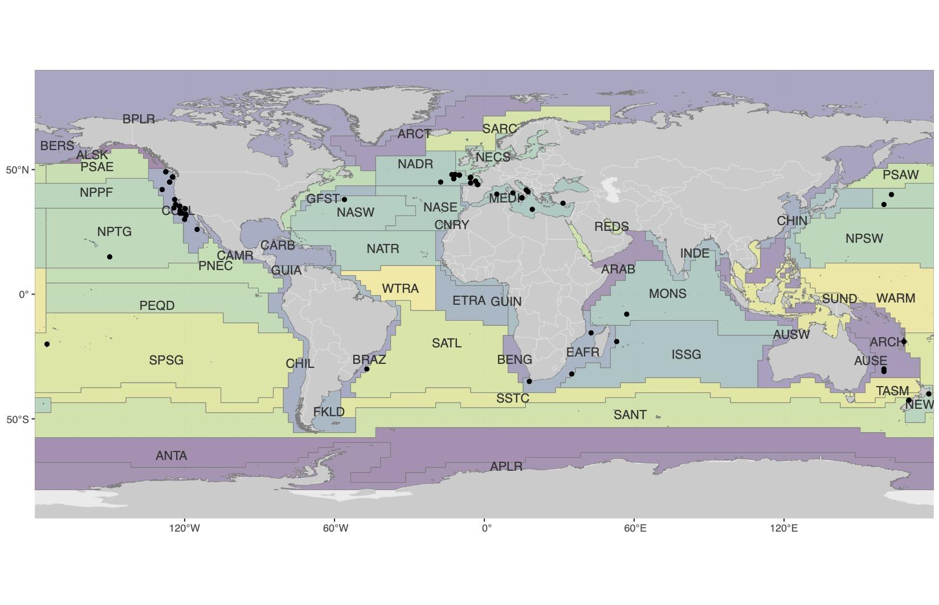

**Figure 1.** Geographic distribution of published albacore tuna diet papers, reports and from 1880–2020, including Longhurst biogeographical province codes (**n = add number of papers/obs**).

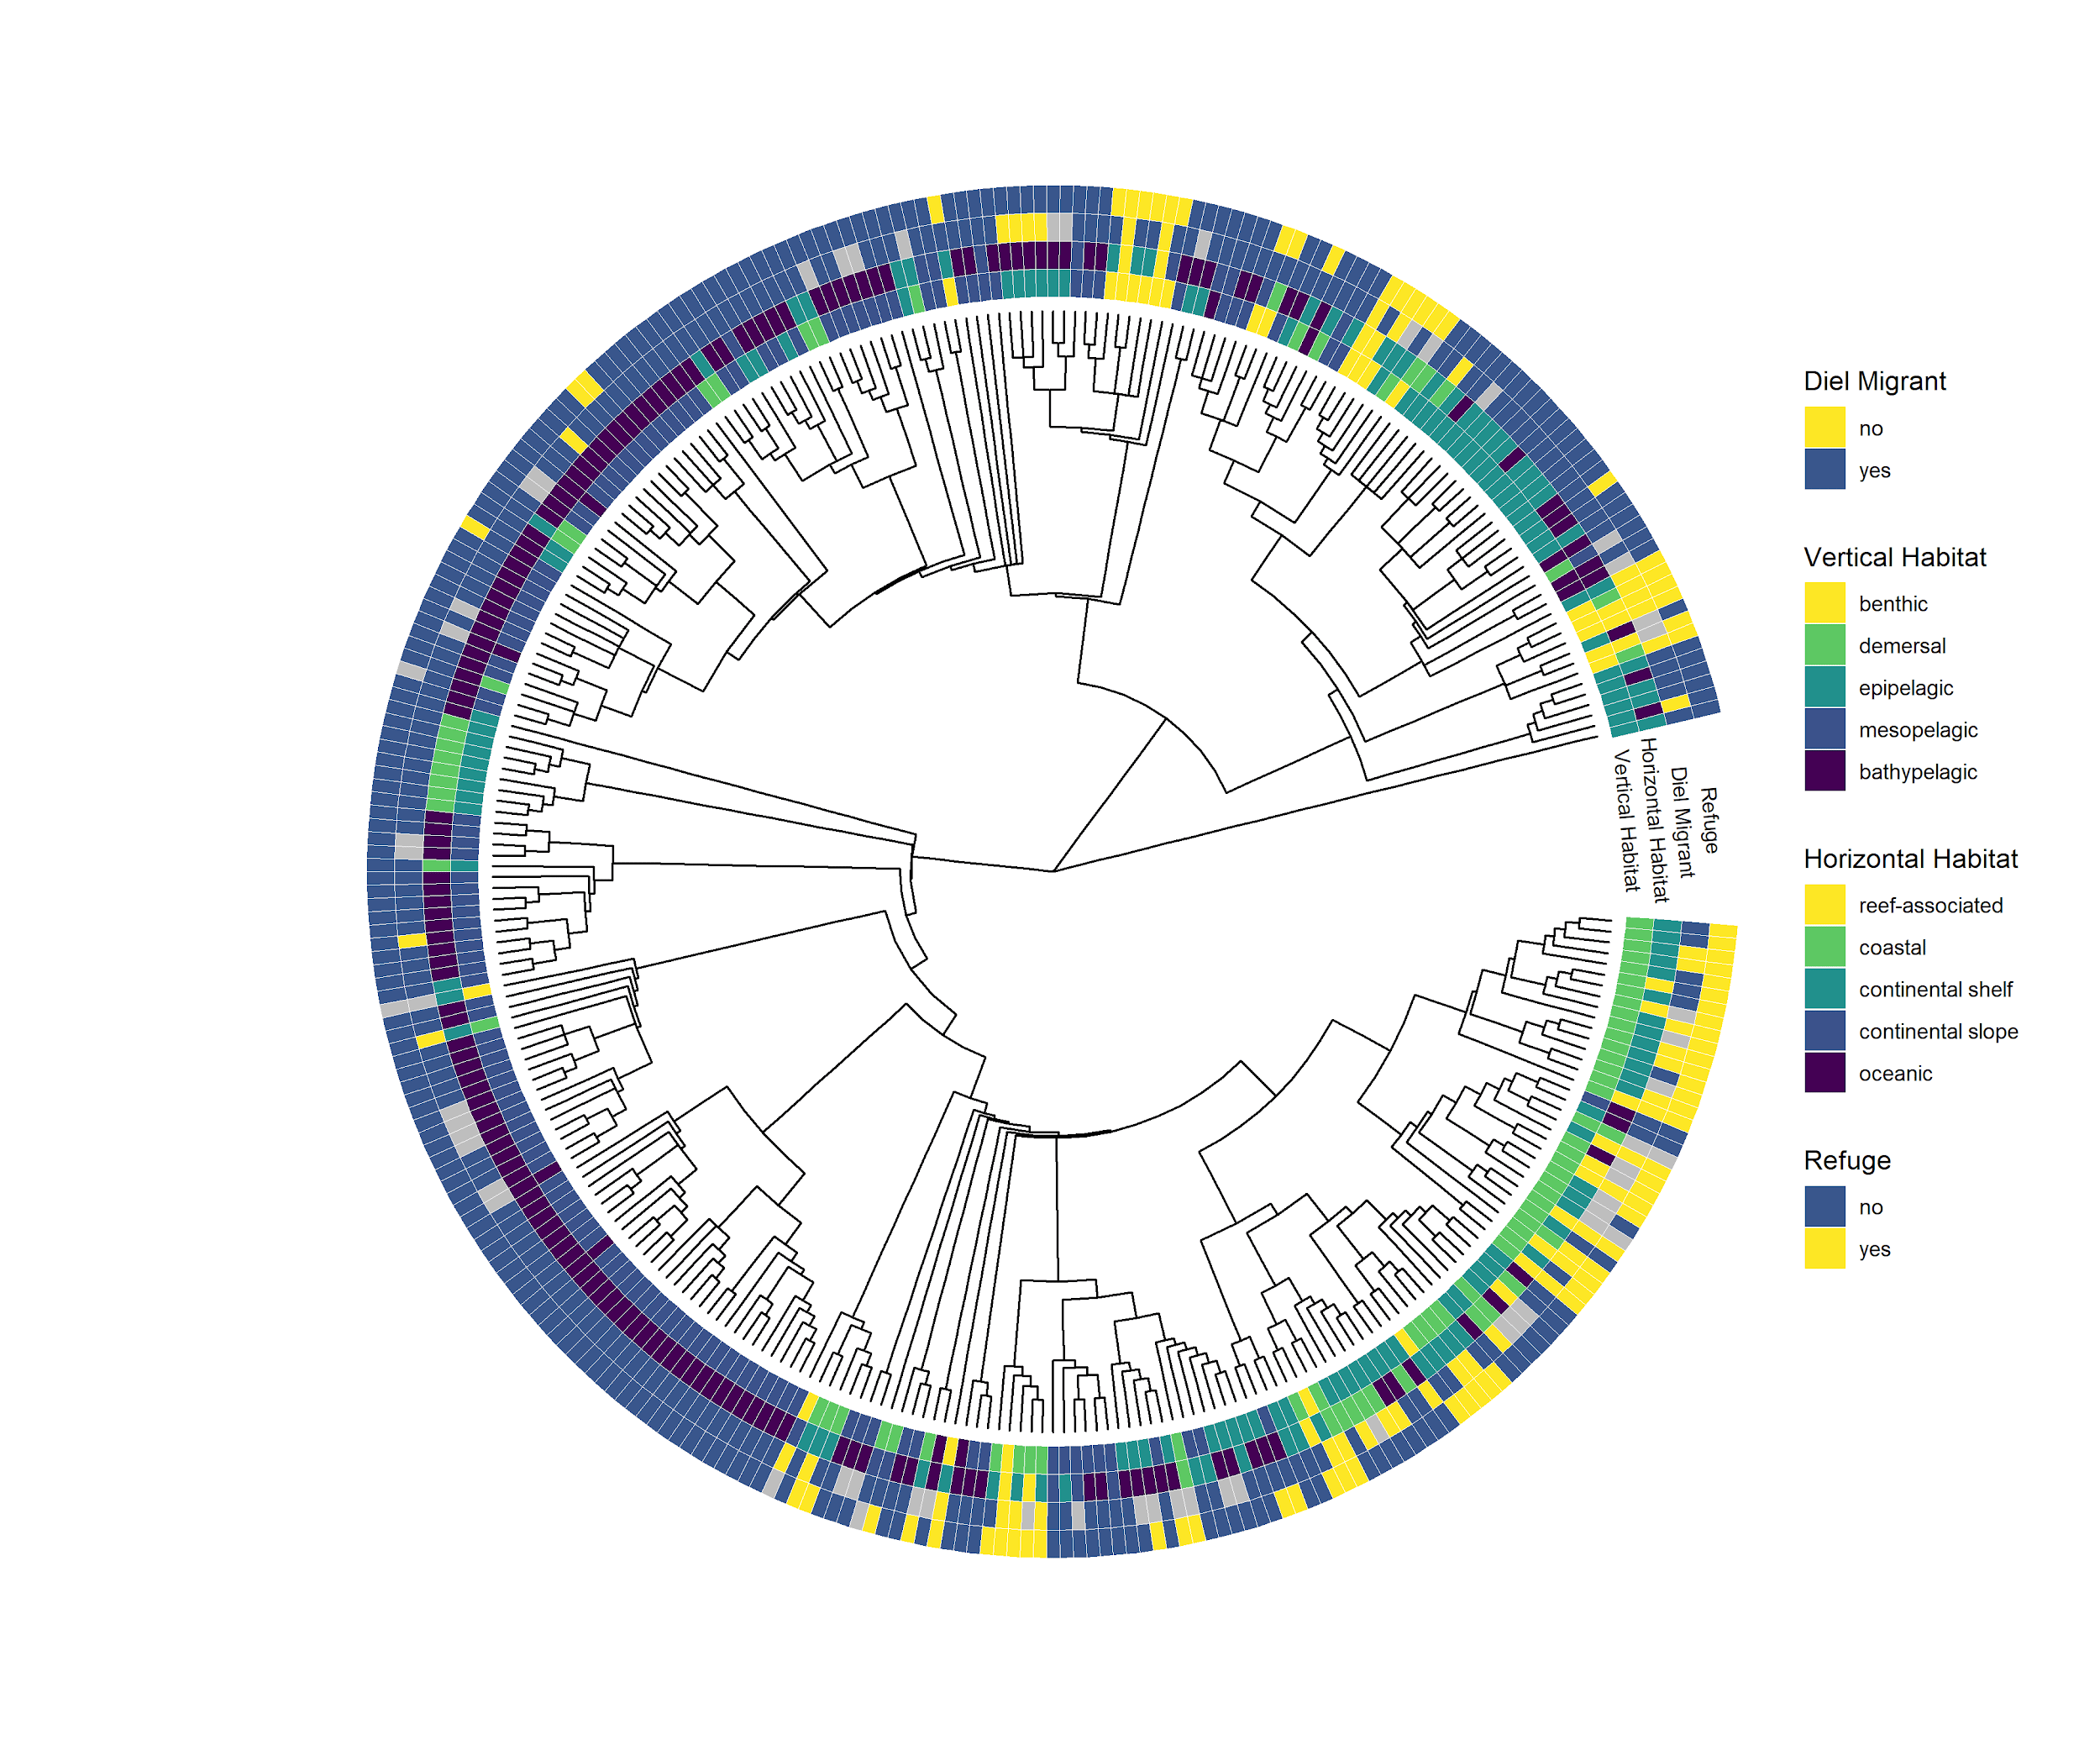

**Figure 2.** Prey and trait diversity for **305** taxa were identified to species, parsed to a phylogenetic classification tree and paired with trait information for prey species’ habitat use information. The following trait and taxonomic information are available in the electronic supplementary materials: a) class/species alone, b) relative importance in albacore diets, c) / d) other traits? e) more morph traits, f) behaviour, g) fisheries + information (Figs. …, ESM).

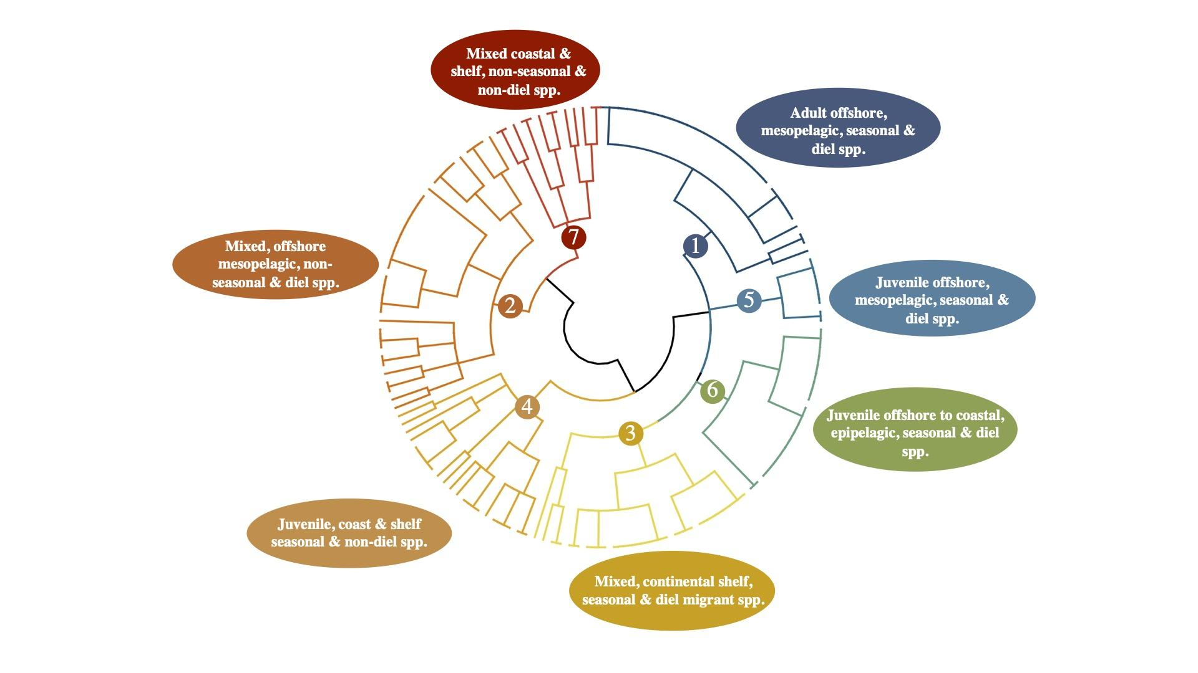**Figure 3.** Illustrating a) cluster dendrogram with 7 optimal clusters identified using hierarchical divisive clustering, and b) multivariate relationships between clusters using nMDS using prey group ID as grouping factor (ESM). Note: could move labels to table/flow-chart adjacent to the dendrogram.

## 

**Figure 4.** Correlation coefficients for the interaction between traits and environment (4th corner model solution), and for identified functional groups (clusters) and environment (Fig. …, ESM). Coefficients for all trait-environment interactions are presented using a (GLM)-LASSO model (Brown *et al.* 2014) and significant relationships between albacore age group and geography sampled with traits are illustrated and coloured in relation to their correlation coefficient, and the strength and direction of the relationship.

Note edit similar to this example:

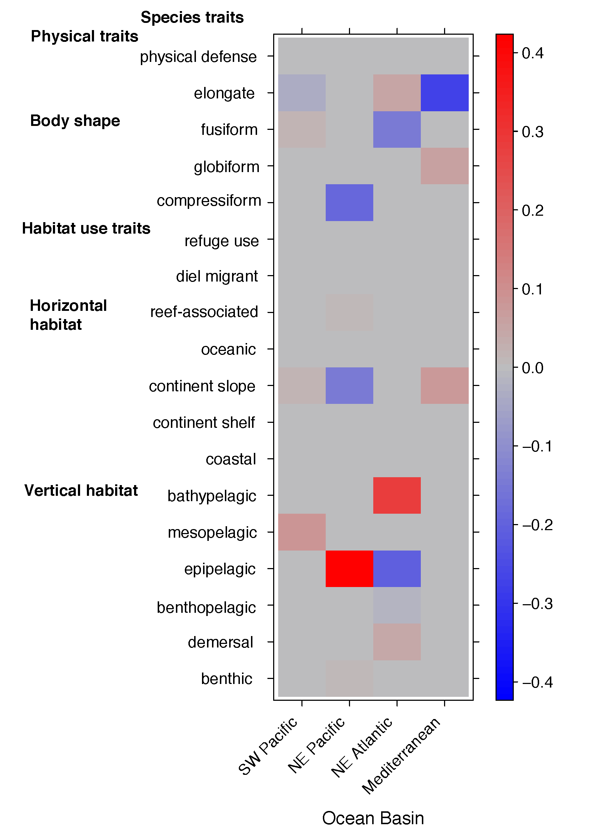

## Electronic Supplementary Material

Document here: [Albacore_diet_review_supplement](https://docs.google.com/document/d/1VNvPpuBC5vCvFNSpCnemlqkrWDuD7HLUTm8aO33Vzw0/edit)